PAI Assignment 2

Q1:
import requests as req
with open("api.txt", "w") as file:
file.write("https://api.cricapi.com/v1/currentMatches")

print("api.txt file created successfully!")

try:
with open("api.txt","r") as file:
url=file.readline().strip() # using strip to leave the extra spaces
print(url)
except FileNotFoundError:
print("Error: 'api.txt' not found.")

param={
"apikey": "ef61457d-fd8b-469f-a7a6-9cd089167c02",
"offset": 0
}
try:
response=req.get(url,params=param)

if response.status_code==200:
data=response.json()
print("API response recieved.")

print("API Status Summary:")
for key,value in data.items():
if key not in ("data","apikey"):
print(f"{key}: {value}")

if data.get("status")!="success" or "data" not in data or not data["data"]:
print("API Error.")
print(f"Reason: {data.get("reason","unknown error")}")
else:
print("---Current Matches---")
for match in data["data"]:
print("-----------------------------------")
print(f"Match Name : {match.get("name","N/A")}")
print(f"Status : {match.get("status","N/A")}")
print(f"Venue : {match.get("venue","N/A")}")
print(f"Date : {match.get("date","N/A")}")
print("-----------------------------------")

scores=match.get("score")
if scores and isinstance(scores,list):
for innings in scores:
print(f"Inning : {match.get("inning","N/A")}")
print(f"Runs : {match.get("r","N/A")}")
print(f"Wickets : {match.get("w","N/A")}")
print(f"Overs : {match.get("o","N/A")}")
print("-----------------------------------")
else:
print("No score data avaiable yet.")
print("--------------------------------------------------------------------------")

else:
print(f"HTTP Error: {response.status_code}")
print(response.txt())

except req.exceptions.RequestException as e:
print("Network Error: Unable to reach API.")
print(f"Details: {e}")
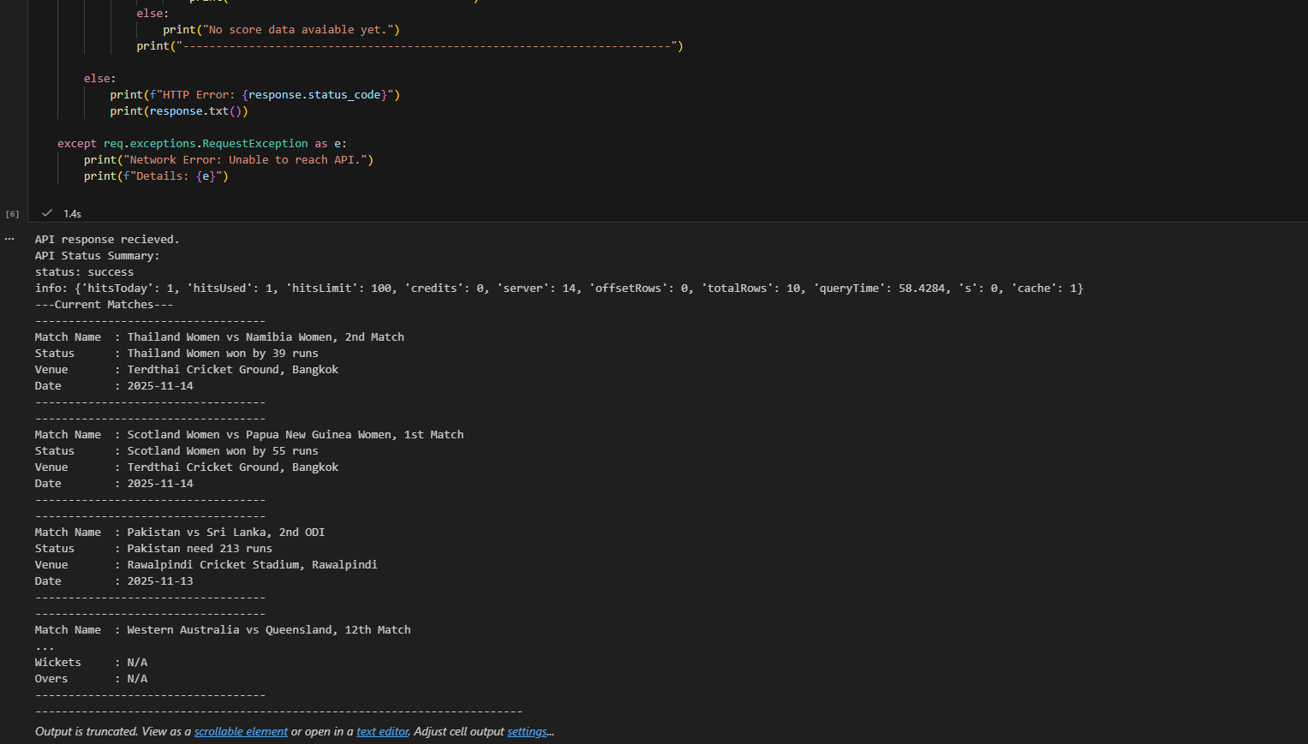

Q2:
import numpy as np
data=[]
with open("sensor_data.csv","r") as file:
for line in file:
data.append(line.strip().split(","))
print(f"Loaded data: {len(data)} rows, {len(data[0])} columns")
dataArr=np.array(data,dtype=float)
dataArr[dataArr==-999]=np.nan
dataArr[(dataArr<0)|(dataArr>100)]=np.nan

meanPerSensor=np.nanmean(dataArr,axis=0)
meanPerHour=np.nanmean(dataArr,axis=1)
nanCount=np.isnan(dataArr).sum(axis=0)
wrostSensorIndex=np.argmax(nanCount)
wrostSensorInvalids=nanCount[wrostSensorIndex]
print("Average moisture (per sensor):\n", meanPerSensor[:10], "...") # first 10 to make the output simple
print("\nMedian moisture (first 10 hours):\n", meanPerHour[:10])
print(f"\nSensor with most invalid readings: Column {wrostSensorIndex} ({wrostSensorInvalids} NaNs)")
minVal=np.nanmin(dataArr)
maxVal=np.nanmax(dataArr)
normalizedArr=(dataArr-minVal)/(maxVal-minVal)
np.savetxt("sensor_data_normalized.csv",normalizedArr,delimiter=",",fmt="%.4f",header="Normalized Sensor Data",comments="")
print("Done!") 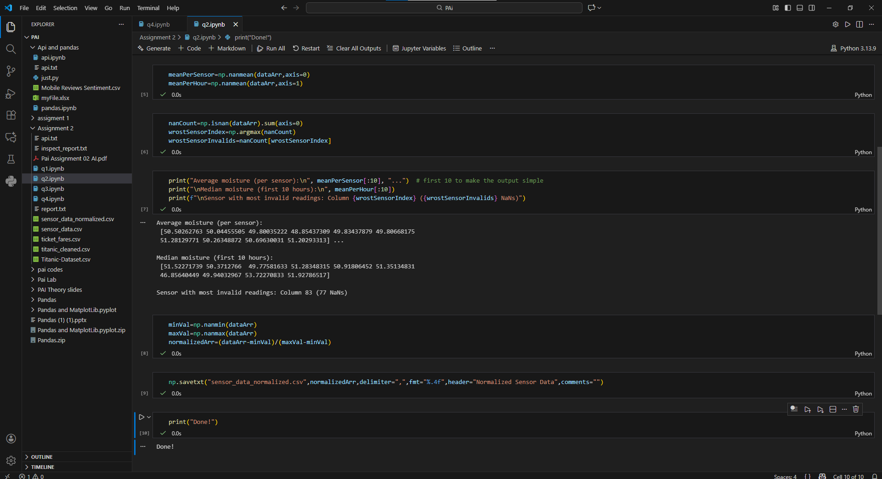

Q3:
import pandas as pd
data=pd.read_csv("Titanic-Dataset.csv")
data.columns
reportLines=[]
reportLines.append("Column, Dtype, % Missing ")
for col in data.columns:
dtype=data[col].dtype
missing=data[col].isna().mean()*100
reportLines.append(f"{col}, {dtype}, {missing:.2f}% \n")
with open("inspect_report.txt","w") as file:
file.writelines(reportLines)
print("Inspect report written sucessfully.")
print("preview (10 lines): ")
print("".join(reportLines[:10]))
groupMedian=data.groupby(["Pclass","Sex"])["Age"].transform("median")
data["Age"]=data["Age"].fillna(groupMedian)
data["Age"].info()
if data["Embarked"].mode().size>0:
embarkedMode=data["Embarked"].mode()[0]
else:
embarkedMode="S"
data["Embarked"].fillna(embarkedMode)
if "Cabin" in data.columns:
data=data.drop(columns=["Cabin"])
data.head(3)
data["familySize"]=data["SibSp"]+data["Parch"]
data["IsAlone"]=(data["familySize"]==0).astype(int)
data["Age"]=data["Age"].astype(int)
data.head(2)
data.to_csv("titanic_cleaned.csv",index=False)
print(f"Cleaned Data saved.") 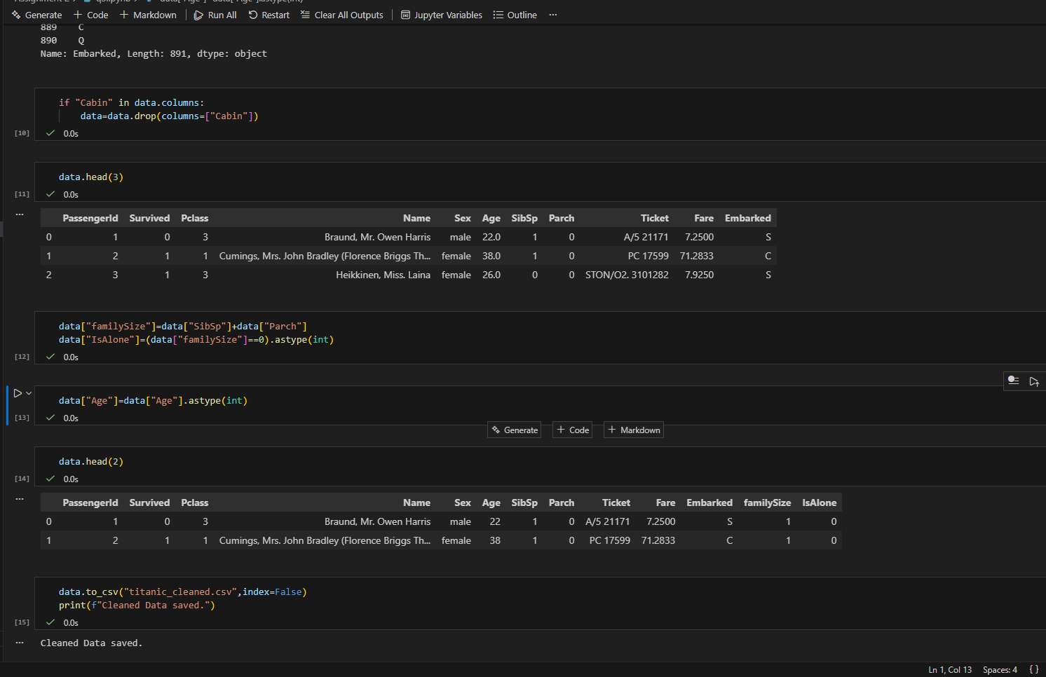

Q4:
import pandas as pd
da=pd.read_csv("titanic_cleaned.csv")
dd=pd.read_csv("ticket_fares.csv")
df = da.merge(dd, how="left", on="Ticket")
df.columns
df=df.drop(columns=["Fare_x"]).rename(columns={"Fare_y":"Fare"})
df.head(3)
ageBins=[-1,12,19,59,120]
ageLabels=["Child","Teen","Adult","Senior"]
df["AgeGroup"]=pd.cut(df["Age"],bins=ageBins,labels=ageLabels)
survivalRates=df.groupby(["Sex","AgeGroup"])["Survived"].mean().unstack() # unstack is used to remove the last line saying the dtpye of the object
survivalRates
childSurvivalRate=df[df['AgeGroup']=='Child']['Survived'].mean()
womenSurvivalRate=df[(df["Sex"]=="female") & (df["AgeGroup"]!="Child")]["Survived"].mean()
menSurvivalRate=df[(df["Sex"]=="male") & (df["AgeGroup"]!="Child")]["Survived"].mean()
with open("report.txt","w") as file:
file.write("---Hypothesis 1: Women And Childern First!---\n")
file.write("\nSurvival Analysis by age and sex group\n")
file.write(f"\n{survivalRates}\n")
file.write("--Conclusion--\n")
file.write(
f"Childern Survival rate: {childSurvivalRate:.2%}\n"
f"Women Survival rate: {womenSurvivalRate:.2%}\n"
f"Men Survival rate: {menSurvivalRate:.2%}\n"
f"Thus the data shows that the *Women And Childern First* drill was followed."
)

survivalRatesbyPclass = df.groupby(['Pclass'])['Survived'].mean()
survivalRatesbyPclass
df["FareBin"]=pd.qcut(df["Fare"],q=4,labels=["Low","Medium","High","VeryHigh"],precision=2)
survivalRatesByFareBin=df.groupby("FareBin")["Survived"].mean()
highPclass=survivalRatesbyPclass[1].round(2)
lowPclass=survivalRatesbyPclass[3].round(2)

highFare=survivalRatesByFareBin["VeryHigh"].round(2)
lowFare=survivalRatesByFareBin["Low"].round(2)
with open("report.txt","a") as file:
file.write("\n\n\n---\n\n")
file.write("Hypothesis 2: Wealth\n")
file.write("\nMethod A (Pclass) Survival Rates:\n")
file.write(survivalRatesbyPclass.apply(lambda x: f'{x:.2%}').to_string() + "\n\n")

file.write("Method B (FareBin) Survival Rates:\n")
file.write(survivalRatesByFareBin.apply(lambda x: f'{x:.2%}').to_string() + "\n\n")

file.write("Conclusion Comparison of Methods A and B:\n")
file.write(
f"The data clearly shows a correlation between wealth and survival\n. "
f"Passengers in the highest wealth bracket (1st Class and Very High Fare) had advantage: \n"
f" 1st Class passengers survived at a rate of {highPclass:.2%}, and those paying the highest fares survived at {highFare:.2%}.\n"
f"While, passengers in the lowest wealth bracket (3rd Class and Low Fare) were the least likely to survive: \n"
f" 3rd Class passengers had a survival rate of only {lowPclass:.2%}, while those in the lowest fare quantile survived at {lowFare:.2%}.\n"
f"Because both Method A (discrete class) and Method B (continuous fare) show similar trends higher wealth equals higher survival the hypothesis that socio-economic status determined access to lifeboats is strongly supported."
) 